“JUnit Testing Exercises”
Exercise 1: Setting Up JUnit Scenario: You need to set up JUnit in your Java project to start writing unit tests.
SOLUTION:
1.Calculator.java
package com.example.JUnitDemo;
public class Calculator {
public int add(int a, int b) {
return a + b;
}
}
2.AppTest.java
package com.example.JUnitDemo;
import static org.junit.Assert.assertTrue;
import static org.junit.Assert.assertEquals;
import static org.junit.Assert.assertNotEquals;
import org.junit.jupiter.api.Test;
public class AppTest {
@Test
public void testAdd() {
Calculator calc = new Calculator();
int result = calc.add(2, 3);
assertEquals(5,result);
}
@Test
public void shouldAnswerWithTrue() {
System.out.println("This test is running1...");
assertTrue(true);
}
@Test
public void shouldAnswerWithTrue1() {
System.out.println("This test is running2...");
int actualresult=2+2;
assertEquals(4,actualresult);
}
@Test
public void shouldAnswerWithTrue2() {
System.out.println("This test is running2...");
int actualresult=2+2;
assertNotEquals(5,actualresult);
}
}

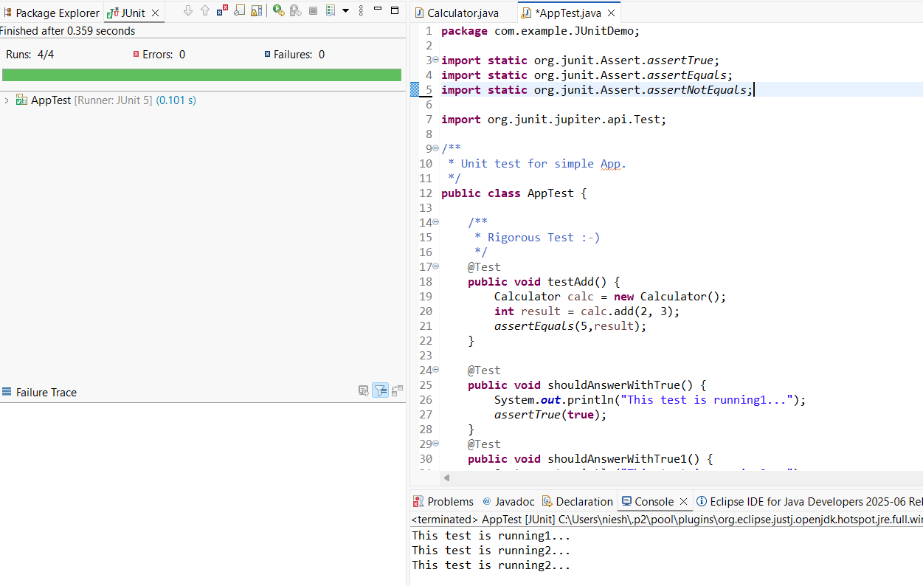

----------------------------------------------------------------------------------------------------------------

Exercise 2: Writing Basic JUnit Tests Scenario: You need to write basic JUnit tests for a simple Java class.

SOLUTION
1.Base.java
package Utilities;
public class Base {
public static boolean isEven(int number) {
return number % 2 == 0;
}
}

2.BaseTest.java
package Utilities;
import org.junit.jupiter.api.Test;
import static org.junit.jupiter.api.Assertions.*;
public class BaseTest {
@Test
void testIsEven1() {
System.out.println("Checking Test Case 1");
assertFalse(Base.isEven(19));
}
@Test
void testIsEven2() {
System.out.println("Checking Test Case 2");
assertTrue(Base.isEven(18));
}
}

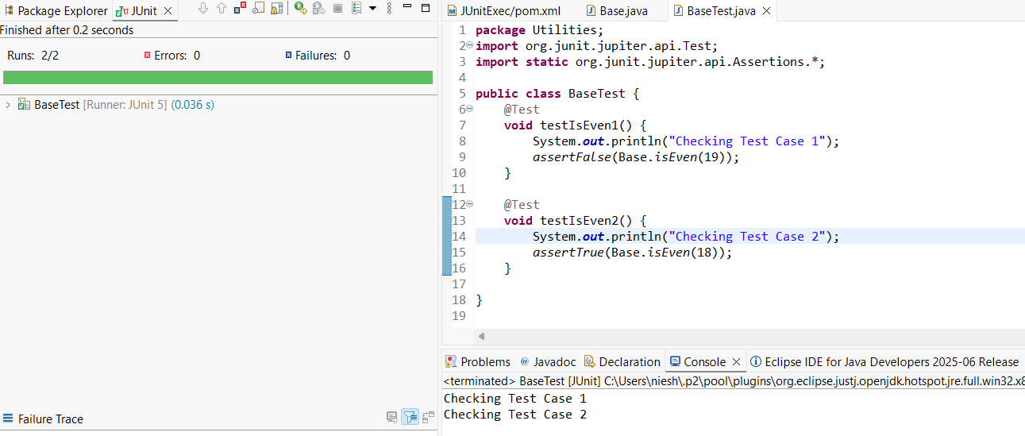
----------------------------------------------------------------------------------------------------------------
Exercise 3: Assertions in JUnit Scenario: You need to use different assertions in JUnit to validate your test results.
SOLUTION
1.AssertionsTest.java
package Utilities;
import org.junit.jupiter.api.Test;
import static org.junit.jupiter.api.Assertions.*;

public class AssertionsTest {
@Test
public void testAssertions() {
System.out.println("Running assertion test...");
// Assert equals
assertEquals(5, 2 + 3, "2 + 3 should equal 5");
// Assert true
assertTrue(5 > 3, "5 should be greater than 3");
//assert false
assertFalse(5 < 3, "5 should not be less than 3");
//assert null
assertNull(null, "Should be null");
//assert not null
assertNotNull("JUnit", "Should not be null");
System.out.println("Assertions passed.");
}
}
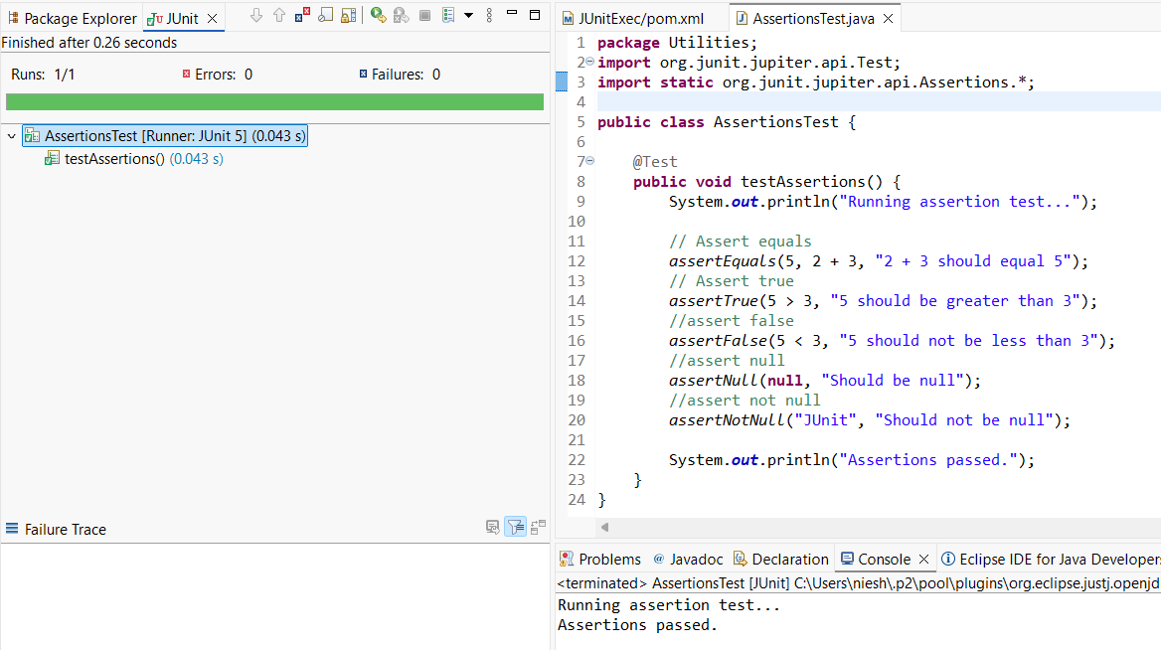

----------------------------------------------------------------------------------------------------------------
Exercise 4: Arrange-Act-Assert (AAA) Pattern, Test Fixtures, Setup and Teardown Methods in JUnit Scenario: You need to organize your tests using the Arrange-Act-Assert (AAA) pattern and use setup and teardown methods.
SOLUTION

1.BankAccount.java
package Utilities;
public class BankAccount {
private int balance;

public BankAccount(int initialBalance) {
this.balance = initialBalance;
}

public void deposit(int amount) {
balance += amount;
}

public boolean withdraw(int amount) {
if (balance >= amount) {
balance -= amount;
return true;
} else {
return false;
}
}

public int getBalance() {
return balance;
}
}
2.BankAccountTest.java
package Utilities;

import org.junit.jupiter.api.BeforeEach;
import org.junit.jupiter.api.AfterEach;
import org.junit.jupiter.api.Test;

import static org.junit.jupiter.api.Assertions.*;

public class BankAccountTest {

private BankAccount account;

@BeforeEach
void setUp() {
System.out.println("Setting up...");
account = new BankAccount(100); // Arrange: start with ₹100
}

@AfterEach
void tearDown() {
System.out.println("Cleaning up...");
account = null;
}

@Test
void testDeposit() {
// Act
account.deposit(50);

// Assert
assertEquals(150, account.getBalance(), "Balance should be 150 after deposit");
System.out.println("Running Deposit Method");
}

@Test
void testWithdrawSuccess() {
// Act
boolean result = account.withdraw(60);

// Assert
assertTrue(result, "Withdrawal should be successful");
assertEquals(40, account.getBalance(), "Balance should be 40 after withdrawal");
System.out.println("Running WithDrawSuccess Method");
}

@Test
void testWithdrawFail() {
// Act
boolean result = account.withdraw(200);

// Assert
assertFalse(result, "Withdrawal should fail");
assertEquals(100, account.getBalance(), "Balance should remain 100");
System.out.println("Running Deposit Method");
System.out.println("Running WithDrawFail Method");
}
}




